**badge system[xinyue]**

1. motivation

2. implementation

3. discussion

1. **Motivation**

We want the badge system to work as a incentive method for encouraging users to explore our website more and use it everyday.

According to the theory of gamification, utilizing users’ urge to collect all kinds of badges, we guided users to try every function of our program and award them for continuing using these functions.

1. **Implementation**

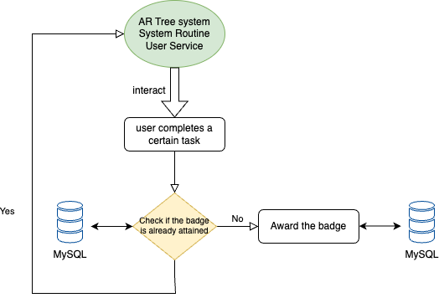

The core functions of the badge system are awarding badges, badge querying and badge information retrieval — all involve interaction with the client, server and database for the badge system. The interaction between the badge system, other systems, and the database is illustrated in the diagram above.

* 1. Awarding badges

When the user completes a certain task or meets a criteria, the back end checks when the criteria is triggered. This involves interaction with other sections in the backend like UserTree, SystemRoutine, UserService and etc.

We query the database to see if the badge is already attained by the user and if not and the criteria is met, we insert a record into the user-badge table to award the badge.

* 1. Badge querying

The front end needs to display the badges that users earned. So we need to return a list of badges from the database. The list include the id and description of the badges.

We implement this query of badges by user id. When the front-end requests the list of badges for a user, the backend uses badgeMapper.selectList to retrieve all badges associated with the user's ID.

* 1. Badge information retrieval

Information of the 12 badges is stored in the `badge` table within the MySQL database. Information of users is stored in the `user` table. Badge and user id stored in these two tables serves as foreign key together, forming a composite key in `user_badge` table to uniquely identify each entry. This table also includes the time when the badge was earned.

1. **Discussion**
   1. Firstly we designed and sorted the badges into 12 kinds. One of these is consistency badges awarded for completing the daily routine for some consecutive days. Another type was social interaction badges awarded for sharing link of the already attained badges. Unfortunately, due to a lack of development time, we changed these two badges into other types.
   2. After finishing the first round of testathon, we changed the way how the badges were displayed in the front end with the effect of unattained badges looking grey and the already attained badges showing its original color.
   3. In the final refinement stage, we reckoned that the description of a badge should be seen by users so that they can know the criteria for earning a badge, which makes the system much more clearer and helpful.